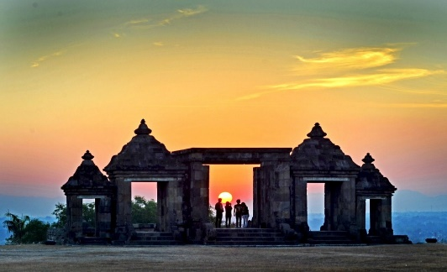
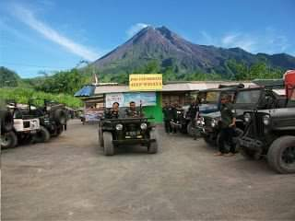
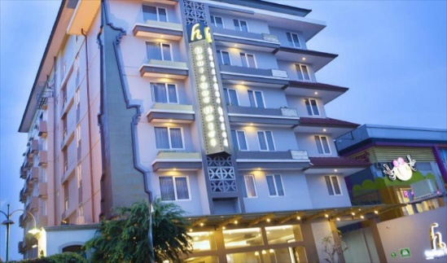
4 DAYS 3 NIGHTS JOGJA SOLO TOUR

Day 1 - ARRIVAL JOGJA – HALF DAY TOUR JOGJA (L,D)
Arrival in jogja airport in the afternoon - lunch at local resto - proceed to Kota Gede area for the centre of silver crafts industry – showrrom and manufacture of jogja chocolate tugu and leather craft gallery – proceed to dune sand/gumuk pasir and parangtritis beach until sunset if possible – dinner at local resto - check in hotel

Day 2 - CITY TOUR - BOROBUDUR TEMPLE – MERAPI VOLCANO TOUR (B,L,D)
Breakfast at hotel - visit the manufature of jogja original batik to see the production process and the collection - proceed to kali adem village for merapi volcano tour to see the view of merapi volcano with jeep - lunch at local resto - borobudur temple – dinner at local resto - back to hotel

Day 3 - SOLO CITY TOUR – LAWEYAN / KLEWER MARKET (B,L,D)
Breakfast at hotel – solo tour visiting mangkunegaran palace and antique traditional market of Pasar Triwindhu - lunch at local resto – Pasar Klewer or Pusat Grosir Solo (PGS) – dinner at local resto -back to jogja / hotel

Day 4 - TRANSFER OUT (B)
Breakfast at hotel - check out – continue shopping time (malioboro street if possible) - drop to jogja airport

4D3N Jogja Solo tour (price per person) | Twin share |  | Child with bed | Child no bed
3*hotel cordela or hotel H boutique or similiar | S$410 |  | S$310 | S$205
Include:  - Private transport air cond  - 2Nights Accommodation with breakfast  - Meals as per itinerary/program  - Jeep 4x4 for merapi volcano tour (1 jeep has max capacity up to 4 pax)  - Driver cum guide  - Mineral water on tour |  | Not Include:  - Return flight ticket and Travel insurance  - Personal expenses  - Everything else not stated above
Noted :
- This price will be valid only on low season until 20 March 2021
- Price valid for overseas market
- Not valid for peak season of long holiday of idul fitri 22 Mei - 7 Juni 2020, christmas and new year 21 desember 2020 - 3 Januari 2021
- No refund
- Infant below 2years old FREE

