4 DAYS 3 NIGHTS MALANG – BATU – BROMO
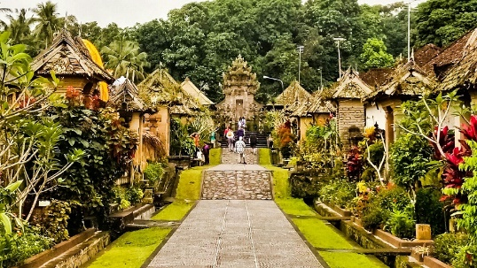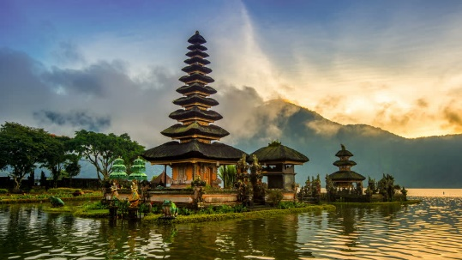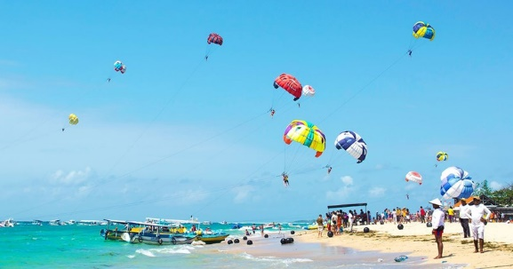

Day 1 - Arrival (-)
Arrive at Abdul Rachman Saleh Airport → Meet with driver and transfer to hotel

Day 2 - Bromo Sunrise – Malang Tour (B)
Pickup from hotel at 00.00 and head to Bromo (Breakfast box from hotel) → Arrive at Tumpang and start Bromo Sunrise Tour (Bukit Kingkong - Mt. Batok - Bromo Crater - Sea of Sand – Teletubbies Hill) → Transfer back to hotel → Pickup at 14.30 for Malang City Tour (Idjen Boulevard, Malang City Square, City Hall And Souvenir Shop) → Then visit Kajoetangan Heritage Village And Malang Night Paradise → Transfer back to hotel

Day 3 - Batu City Tour (B)
Breakfast at hotel → Proceed to Batu City and visit Coban Rondo Waterfall + Labyrinth Waterpark. Then proceed to Paralayang Hill, Sky Park, Wooden Treehouse, Rabbit Field & Strawberry Farm for photostop → Contiune with Batu City Tour (Batu City Square & Souvenir Shop) and Museum Angkut / The Legend Star / Batu Night Spectacular → Transfer back to hotel

Day 4 - Departure (B)
Breakfast at hotel → Transfer to Abdul Rachman Saleh Airport

Valid till 31 Mar 2021
4D3N Package per person | Twin share | Single occupancy |  | Chd with bed | Chd No bed
eL Grande Hotel Malang | S$390 | S$460 |  | S$295 | S$195
Include:  - AC transportation (driver, gasoline, all fees)  - Accommodation with breakfast  - Return airport transfer  - Sightseeing tour as stated on the program  - Local guide during tour  - Entrance fee & donation  - Snack box and mineral water |  |  | Not Include:  - Return flight ticket and Travel insurance  - Personal expenses  - Camera Ticket in Museum Angkut for Pocket, DSLR, GoPro Camera IDR30.000 / camera  - Weekend / Public Holiday Surcharge for Bromo National Park Enterance Fee IDR100.000 / pax  - Guide and driver tips  - Everything else not stated above

